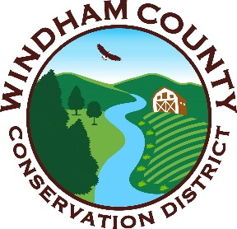
2026 Aquatic Invasive Species Greeter Program
Application for Employment
Name: _____________________________________________________
Telephone you can be reached at: ______________________________
Address ____________________________________________________
Email Address _______________________________________________
☐ Please check here if you are a returning greeter from a previous season and you wish to return. You do not need to fill out the information below. Please include a resume or other summary of relevant experience along with this form, however.

What experience, if any, do you have working with invasive species?

Would you be comfortable working long hours outdoors in the elements (insects, heat, cold, rain)?

Are there any dates that you would be unable to work between May 28 and September 15? (please list)

Would you be interested in working as a substitute greeter (limited days) if regular positions have been filled?

Which water bodies are you willing to work at: (circle all)

Somerset Reservoir Harriman Reservoir Lake Raponda South Pond

Please provide two professional references (not related to you):

1.
Name:
Relationship to You:
Phone:
Email:
2.
Name:
Relationship to You:
Phone:
Email:
Please send via email along with a resume or letter highlighting your relevant skills and experience to Windham Conservation District Executive Director Cory Ross at ross.wcnrcd@gmail.com

