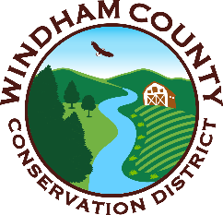
Windham County Natural Resources Conservation District
28 Vernon Street, Suite 332
Brattleboro, VT, 05301
802-689-3024

Wildlife of Windham County Photo Contest

Windham County Natural Resources Conservation District wants to show off the amazing wildlife of Windham County! We invite you to submit up to three of your photos of wildlife in Windham County for our 2027 calendar. If your photo gets selected for use in the calendar, you get a free calendar! The top three ranked photos will get prizes from local businesses such as gift cards or swag! Participants must agree to the following contest rules below (also found at https://www.windhamcountynrcd.org/wildlife-of-windham-county)
Contest Rules:
- Photos must have been taken in Windham County, VT.
- All photos must be original work, taken by the entrant. Photos must not infringe upon the trademark, copyright, moral rights, intellectual rights or rights of privacy.
- Entrants may submit 3 photos.
- AI-generated images will not be considered.
Selection process:
- WCNRCD will rank the photos based on:
  - Adhering to wildlife theme
  - Image in focus
  - Pixel size (300 minimum DPI)
  - Seasonal category
- The public will vote on the top 3-ranked photos. The most voted image will be displayed on the cover of the calendar.
This contest will run from February to August of 2026. Winners will be notified, and calendars will be on sale in November. Questions can be directed to sullivan.wcnrcd@gmail.com or 802-212-9459.

